// WRITE OPERATION //

#include<stdio.h>

int main(){

FILE \*fp;

fp=fopen("abcd.txt","w");

fputs("Hello King",fp);

printf("Wrie Operattion complete");

fclose(fp);

}

OUTPUT:

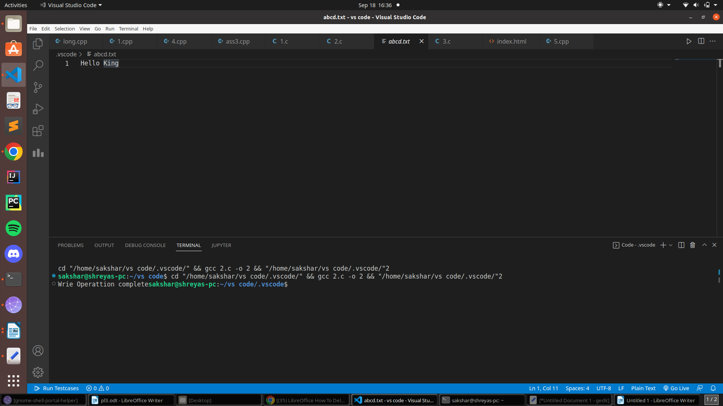

// READ OPERATION //

#include<stdio.h>

int main(){

FILE \*fp;

fp=fopen("abcd.txt","r");

char ch;

while(!feof(fp))

{

ch=fgetc(fp);

printf("%c",ch);

}

fclose(fp);

}

OUTPUT:

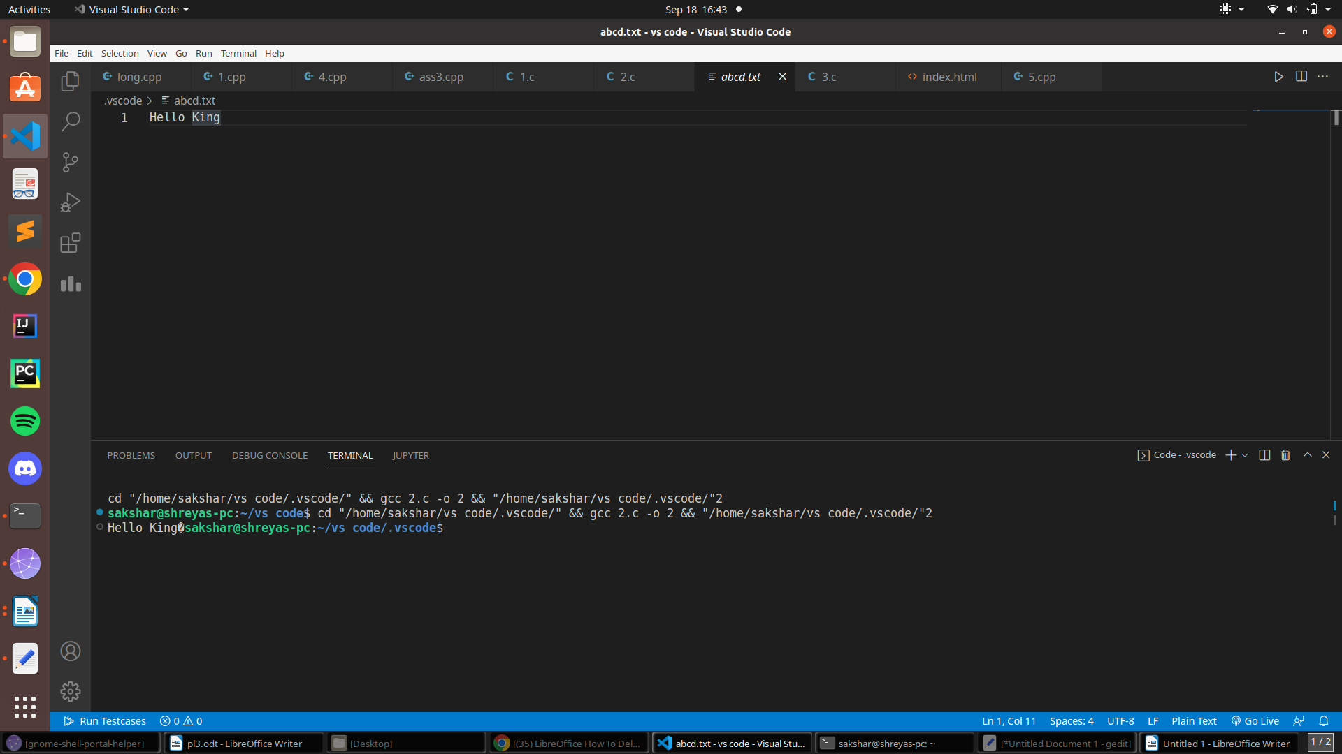

// RECURSOON PROBLEM //

#include <stdio.h>

int palimdrome(int n)

{

if (n == (int)revs(n))

{

return 1;

}

return 0;

}

int revs(int n)

{

int r;

static int s = 0;

if (n != 0)

{

r = n % 10;

s = s \* 10 + r;

revs(n / 10);

}

else

return s;

return s;

}

int main()

{

int n;

scanf("%d", &n);

if (palimdrome(n) == 1)

{

printf("Given Number is palindrome");

}

else

{

printf("Given Number is not palindrome");

}

return 0;

}

OUTPUT:

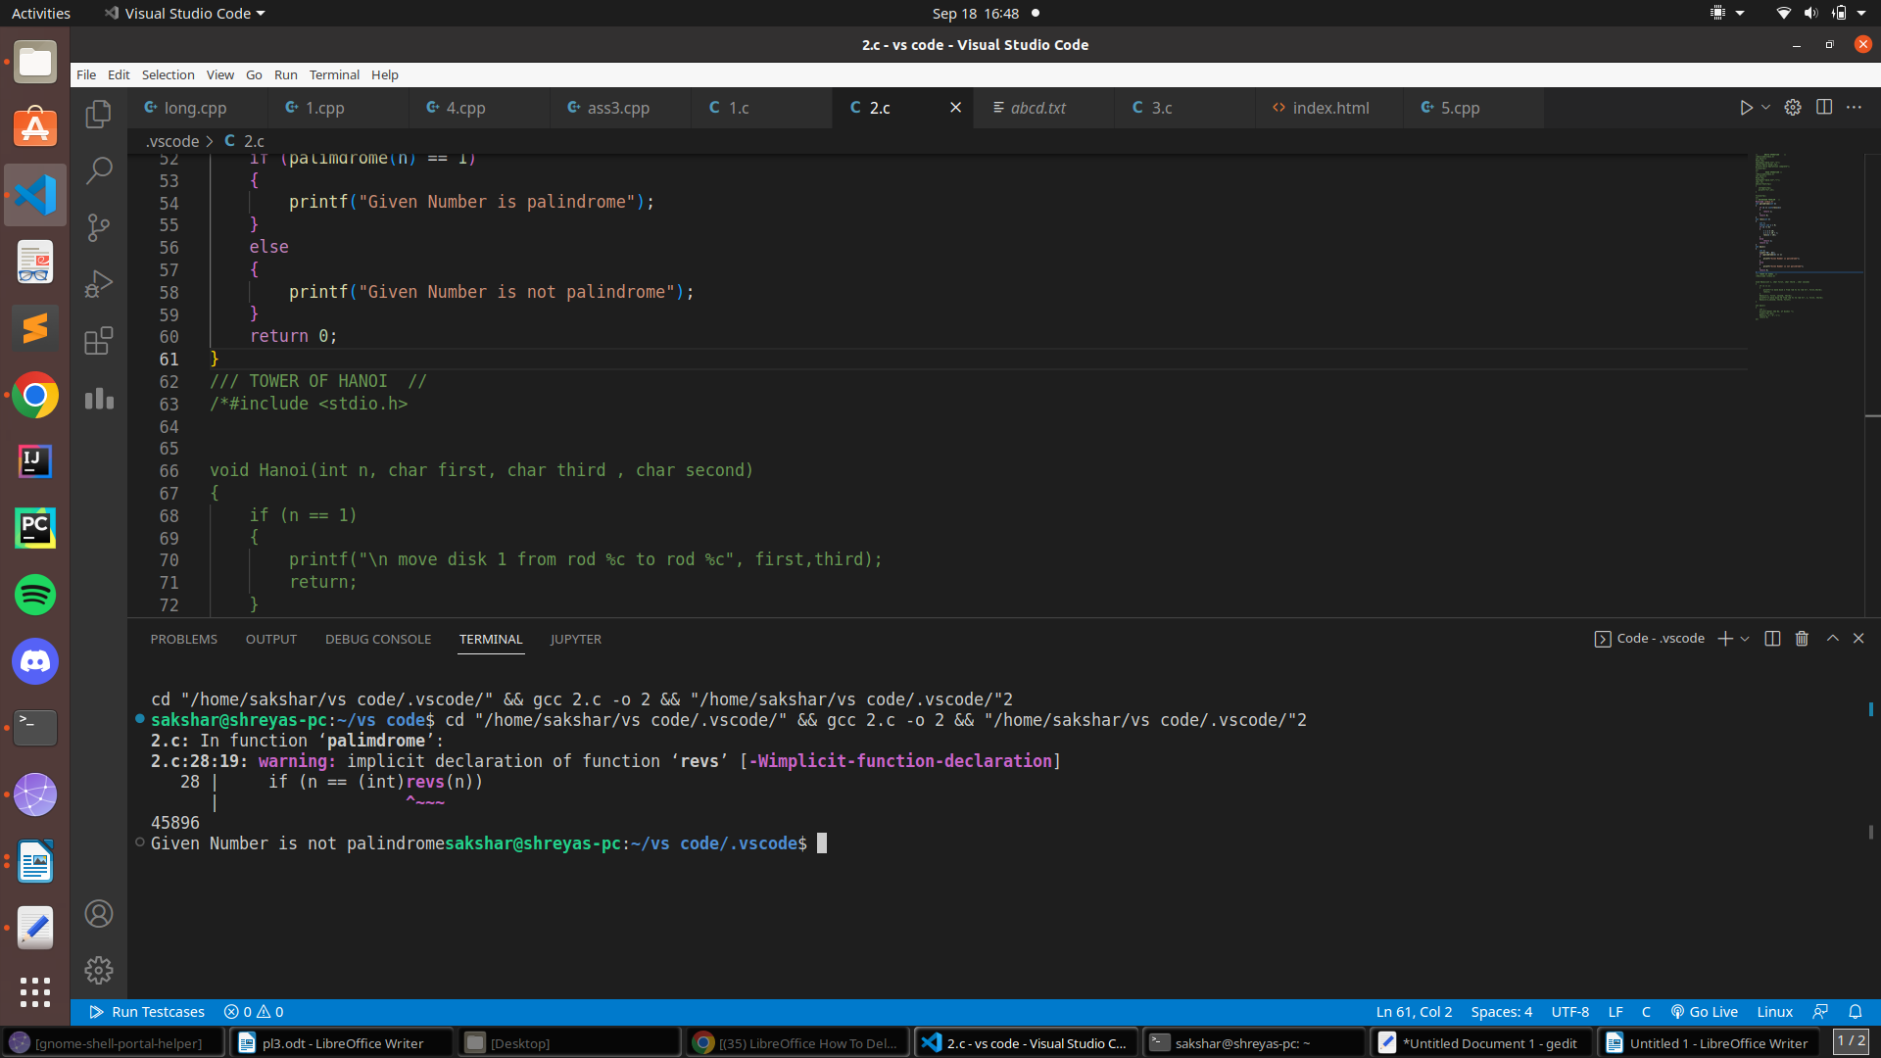/// TOWER OF HANOI //

#include <stdio.h>

void Hanoi(int n, char first, char third , char second)

{

if (n == 1)

{

printf("\n move disk 1 from rod %c to rod %c", first,third);

return;

}

Hanoi(n-1, first, second, third);

printf("\n move disk %d from rod %c to rod %c", n, first, third);

Hanoi(n-1,second, third, first);

}

int main()

{

int x ;

printf("Enter the No. of disks= ");

scanf("%d",&x);

Hanoi(x,'a','b','c');

return 0;

}

OUTPUT:

